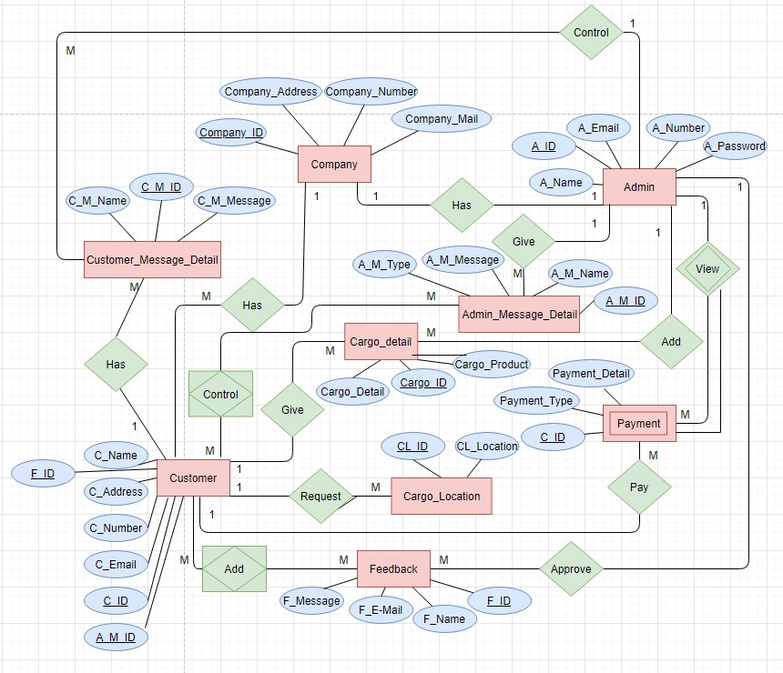

**Relation Schema**:

Company: (Company_ID, *Company_address, Company_number, Company_mail*)

Customer_Message_Detail : (C_M_ID, *C_M_Name, C_M_Message*)

Customer: (C_ID, A_M_ID, F_ID, *C_Address, C_Number, C_Name,*

*C_Email*)

Feedback: (F_ID, *F_Message, F_E-Mail, F_Name*,)

Payment: (C_ID, *Payment_Type, Payment_Detail*,)

Cargo_Detail: (Cargo_ID, *Cargo_Product, Cargo_Detail*)

Admin_Message_Detail: (A_M_ID, *A_M_Name, A_M_Message, A_M_Type*)

Admin: (A_ID, *A_Email, A_Name, A_Number, A_Password*)

Cargo_Location: (CL_ID, *CL_Location*)

Control: (C_ID, A_M_ID,) **P.K. & F.K.**

Add: (F_ID) **P.K. & F.K.**

Foreign Keys are *RED*

Primary Keys are BLUE

**P.K. & F.K.** are **PURPLE**

**BORAN FIRAT KOTANCI**

**B1805.090073**

**CANBERK ÖTEN**

**B1805.090032**

**REHA UYSAL**

**B1605.090025**